**Web Login and Management**

Student Version



Huawei Technologies Co., Ltd.

|  |
| --- |
| **Copyright © Huawei Technologies Co., Ltd. 2020. All rights reserved.**  No part of this document may be reproduced or transmitted in any form or by any means without prior written consent of Huawei Technologies Co., Ltd.  **Trademarks and Permissions**  HW_POS_RBG_Vertical-150ppi.png and other Huawei trademarks are trademarks of Huawei Technologies Co., Ltd.  All other trademarks and trade names mentioned in this document are the property of their respective holders.  **Notice**  The purchased products, services and features are stipulated by the contract made between Huawei and the customer. All or part of the products, services and features described in this document may not be within the purchase scope or the usage scope. Unless otherwise specified in the contract, all statements, information, and recommendations in this document are provided "AS IS" without warranties, guarantees or representations of any kind, either express or implied.  The information in this document is subject to change without notice. Every effort has been made in the preparation of this document to ensure accuracy of the contents, but all statements, information, and recommendations in this document do not constitute a warranty of any kind, express or implied. |

|  |  |
| --- | --- |
| Huawei Technologies Co., Ltd. | |
| Address: | Huawei Industrial Base  Bantian, Longgang  Shenzhen 518129  People's Republic of China |
| Website: | <https://e.huawei.com/> |

**Huawei Certification System**

Huawei Certification follows the "platform + ecosystem" development strategy, which is a new collaborative architecture of ICT infrastructure based on "Cloud-Pipe-Terminal". Huawei has set up a complete certification system consisting of three categories: ICT infrastructure certification, platform and service certification, and ICT vertical certification. It is the only certification system that covers all ICT technical fields in the industry. Huawei offers three levels of certification: Huawei Certified ICT Associate (HCIA), Huawei Certified ICT Professional (HCIP), and Huawei Certified ICT Expert (HCIE). Huawei Certification covers all ICT fields and adapts to the industry trend of ICT convergence. With its leading talent development system and certification standards, it is committed to fostering new ICT talent in the digital era, and building a sound ICT talent ecosystem.

Huawei Certified ICT Associate-Datacom (HCIA-Datacom) is designed for Huawei's frontline engineers and anyone who want to understand Huawei's datacom products and technologies. The HCIA-Datacom certification covers routing and switching principles, basic WLAN principles, network security basics, network management and O&M basics, SDN and programmability and automation basics.

The Huawei certification system introduces the industry, fosters innovation, and imparts cutting-edge datacom knowledge.

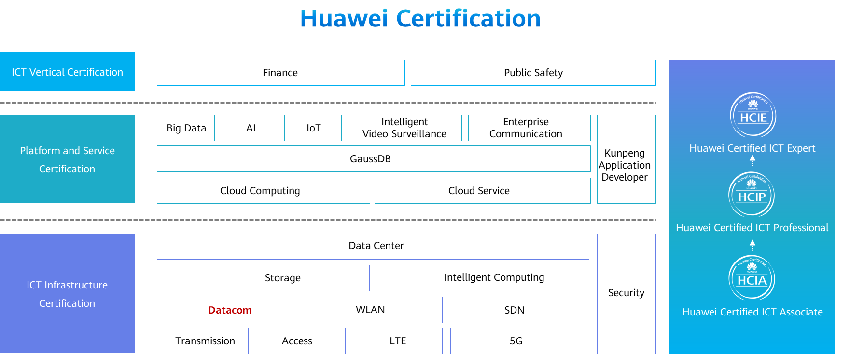

# Web Login and Management

## Background

In addition to the command line interface (CLI), devices provide a graphical user interface (GUI) that is more intuitive and easy to understand for operation and maintenance (O&M). This facilitates device maintenance and use. Most network devices have a built-in web server. Terminals that can communicate with devices at Layer 3 can access the web server through a web browser. By default, the HTTP and HTTPS service are enabled on devices. For security purposes, you are advised to disable the HTTP service. This exercise describes how to log in to network devices through HTTPS and manage the devices.

## Objectives

Upon completion of this exercise, you will be able to:

* Understand HTTP and HTTPS.
* Log in to the web system through HTTPS to manage devices.

## Topology

Lab Topology

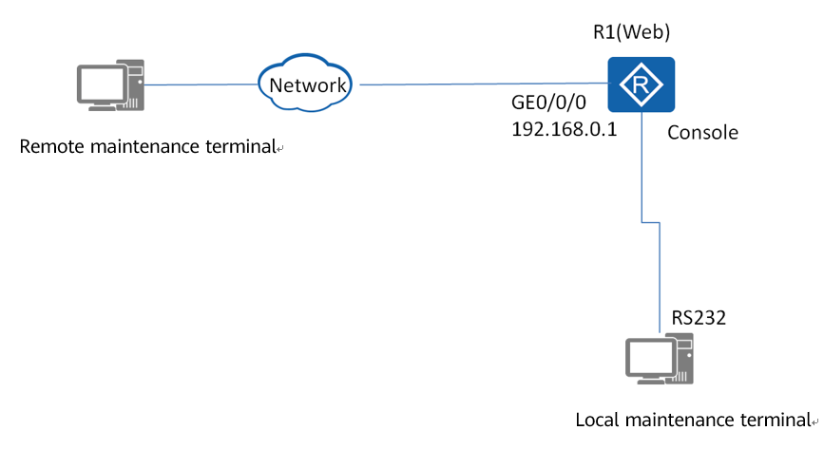

Topology description:

1. In an exercise, the local and remote maintenance terminals can be the same PC.
2. For simplicity purposes, the device to be maintained and the remote maintenance terminal can be in the same network segment. In actual O&M, you can remotely log in to the device from the remote maintenance terminal through the Internet when the terminal can communicate with the device at Layer 3.

## Implementation

### Roadmap

1. Use the terminal emulation software to log in to the device through the console port of the device.
2. Configure the device name and an IPv4 address.
3. Create a user for web login in the AAA view.
4. Enable the web login service and set web login parameters.
5. Log in to the device through the client.

### Procedure

Use the terminal emulation software to log in to the device through the console port. For details, see "Console Login and Management".

Set the device name to **R1** and configure an IP address for GE0/0/0.

Create a user name **huawei** and password **huawei123** for web login, and set the user privilege level to **level 3**, and service type to **http**.

Enable the web server and set related parameters.

#Enable the HTTPS server.



When you enable the HTTPS server, the system may display a message indicating that no SSL policy is configured and the HTTPS service cannot be enabled. In this case, create an SSL policy and bind it to the HTTPS server, as shown in the following figure. Then, enable the HTTPS server again.

#Change the HTTPS server port number to 8443 (443 by default) and the HTTP port number to 8080 (80 by default).

#Configure the interface used to access the web system and set the timeout period to 15 minutes (10 minutes by default).

#Run the **display http server** command to check the HTTPS server status.

On the remote maintenance terminal, enter https://192.168.0.1:8443 in the address box of the browser. The web management platform is displayed, as shown in the following figure.

Web system login page

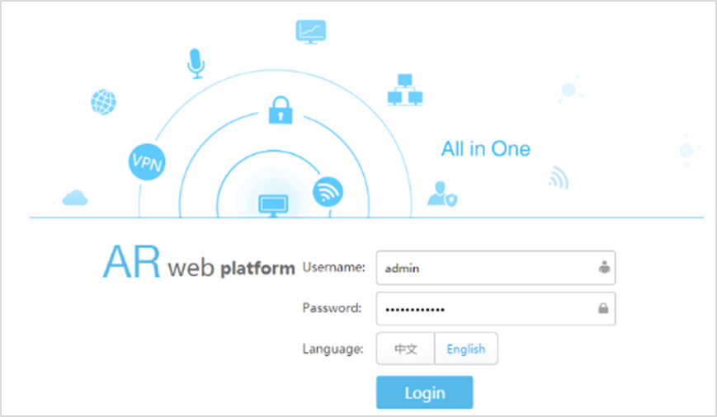

Enter the correct user name and password to log in to the web system, as shown in Figure 1-3. Run the **display http user** command on R1 to check information about online users who have logged in to the web system.

Home page after a successful login to the web platform

